Year 2 - Homework Grid – Autumn Term 2022
Phonics Challenge  Make sure you know how to spell all the Year 1 common exception words (see list) as well as practicing your spelling every week. If you know the Year 1 words start learning the Year 2 words. 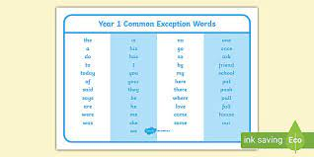 | PE Challenge  How many times can you throw and catch a ball in a row? Can you beat your score? | Maths Challenge  I have set 3 games on Purple Mash.  - Missing numbers in 100 square  - Finding numbers on a number line  - Words and numerals to 100 | Science Challenge  Choose a microhabitat – this could be a rock, log, plant, a pile of leaves, grass ect…- and record what minibeasts you can find.  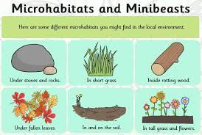
Date completed: | Date completed: | Date completed: | Date completed:
Topic Challenge  Make a list of everything you can find in your home that broadcasts the news in some way.  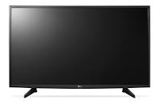 | Writing Challenge  Write some facts about Meerkats. What do you already know? What would you like to know?  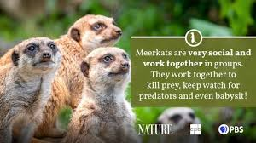 | Art Challenge  Find out about Theresa Elvin (photographer). What is your favourite photograph and why? 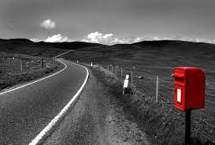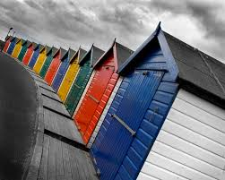 | ICT Challenge  Draw a poster that shows how you can stay safe when using ICT.  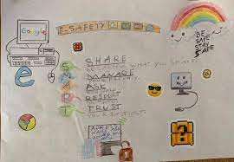
Date completed: | Date completed: | Date completed: | Date completed:
Please complete a minimum of 6 tasks over the coming half term and the 4 pink boxes must be done by the end of October half term.

